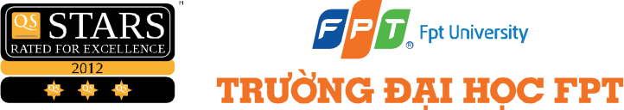

CAPSTONE PROJECT REGISTER

Class Duration time: From 15/7/2026 to 2026
(*) Profession: Software Engineer Specialty: <Cross Platform> <IS>
x

(*) Kinds of person make registers: Lecturer Students
x

- Register information for supervisors (if have)
 | Full name | Phone | E-Mail | Title
Supervisor | Kiều Trọng Khánh |  | KhanhKT@fe.edu.vn | Mr.
Supervisor | FPT |  |  | Mr.
- Register information for students (if have)
 | Full name | Student code | Phone | E-mail | Role in Group
Student | Nguyễn Thế Thắng | SE172839 | 0378540013 | Thangntse172839@fpt.edu.vn | Leader
Student | Phạm Minh Long | SE161578 | 0387591459 | Longpmse161578@fpt.edu.vn | Member
Student | Ngô Nhật Minh | SE185018 | 0982823092 | Minhnnse185018@fpt.edu.vn | Member
Student | Võ Huỳnh Tuấn Đan | SE180108 | 0979310747 | Danvhtse180108@fpt.edu.vn | Member
Students are required to interview for this project by both supervisor and company
- Register content of Capstone Project
  - Capstone Project name
English: AI-Powered Personalized Learning and Mentor Support System for Software Engineering Education
Deployment Place:
Vietnamese: Hệ thống học tập cá nhân hóa và hỗ trợ cố vấn bằng AI cho ngành Kỹ thuật phần mềm
Abbreviation: AITMS
Context:
Software Engineering students often study from materials scattered across learning platforms, PDF files, class announcements, source-code examples, and personal notes. When they get stuck, they may have to wait until the next class or contact a lecturer directly. Generic chatbots can reply quickly, but their answers are not always grounded in the correct Software Engineering course material, and the same explanation may not suit students with different technical backgrounds.

The proposed system provides a focused learning-support workspace for students, lecturers, mentors, and administrators within the Software Engineering program. Materials are collected and indexed only for Software Engineering courses. Students use the system for two purposes: asking theory questions based on approved course materials and requesting guided analysis of source code or programming errors. The system does not aim to support other academic disciplines or provide a general learning-management platform.

AI is used as the first support layer, not as a replacement for lecturers. If the available evidence is weak, the question can be escalated to a mentor. Student feedback and mentor answers do not enter the shared knowledge base automatically. Reusable academic knowledge must be reviewed by a senior mentor or administrator before indexing. This approval step is intended to limit incorrect or class-specific information from affecting future answers.

The system recognizes the following key actors:

Student: studies within the Software Engineering program, asks theory questions, submits code or programming errors for guided analysis, reviews AI answers, and requests human support when needed.

Teacher/Mentor: manages approved Software Engineering learning materials, answers escalated theory or code questions, corrects inaccurate explanations, and proposes verified academic knowledge.

Senior Mentor/Administrator: reviews knowledge candidates and disputed AI answers before approved content is indexed into the course knowledge base.

Software Engineering Academic Administrator: manages semesters, Software Engineering courses, class sections, enrollments, users, subscriptions, and system health information within the program.

System Handler: authenticates users, applies access rules, routes AI requests, retrieves course evidence, stores learning memory, records trace logs, and sends requests to the appropriate human-review flow.

Basic user flows:
Student:
- As a student, I want to sign in and select an enrolled Software Engineering course, so I can access the correct learning scope.
- As a student, I want to ask theory questions or submit code-related questions, so I can receive course-specific explanations and debugging guidance.
- As a student, I want to review AI-supported answers and request teacher or mentor support, so I can obtain reliable help when an answer is unclear or uncertain.
Teacher/Mentor:
- As a teacher or mentor, I want to manage approved learning materials and programming references for my assigned courses, so I can provide students with reliable academic resources.
- As a teacher or mentor, I want to receive and answer escalated questions, so I can correct inaccurate explanations and support students when AI evidence is insufficient.
- As a teacher or mentor, I want to propose reusable academic corrections, so verified knowledge can be considered for future use.
Senior Mentor/Administrator:
- As a senior mentor or administrator, I want to review proposed reusable knowledge and disputed AI answers, so I can approve or reject content before it is indexed into the shared knowledge base.
- As an administrator, I want to manage accounts, semesters, courses, class sections, and enrollments, so I can maintain the Software Engineering academic environment.
System Handler:
- As a system handler, I want to authenticate users, enforce access rules, classify requests, retrieve course evidence, and route uncertain requests for human review, so I can operate a controlled and traceable learning-support workflow.
The diagrams below focus on the main learning and knowledge workflows. They are supporting views of the actor flows above rather than separate products.
Role and terminology note:
- Mentor in this proposal refers to the Teacher who supports students and reviews or corrects AI answers.
- The TEACHER role performs academic review and correction. Final approval for reusable knowledge is performed by SENIOR_MENTOR or ADMIN.
- Supported system roles: STUDENT, TEACHER, SENIOR_MENTOR, ADMIN.
Current system workflow:
The following diagrams describe the principal workflows implemented by the current project. Each diagram focuses on one responsibility so that the proposal can show the retrieval path, human-review controls, and knowledge-update rules clearly.
1. Student Learning Workflow
This figure represents the main student journey: ask a question, route it to theory support or code analysis, receive an answer, and provide feedback.
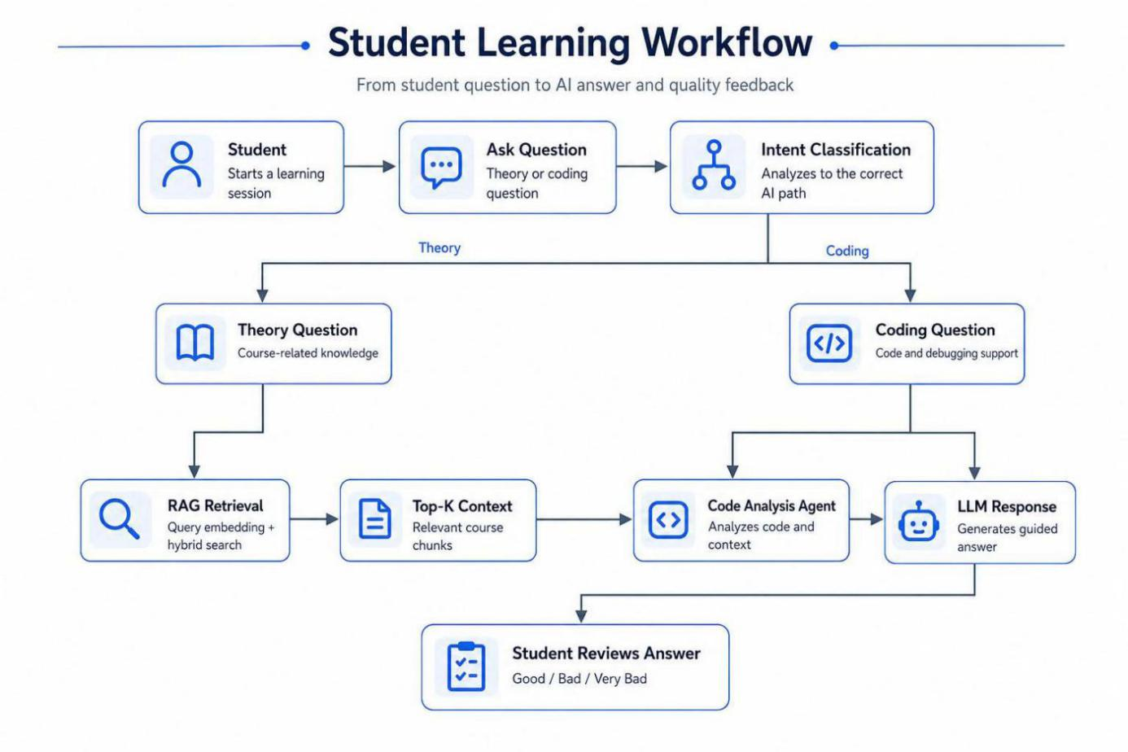
Figure 1. Student question routing from intent classification to theory retrieval or code analysis, followed by answer review.

2. RAG Retrieval Workflow
This figure expands the theory-question branch. In the current implementation, relevant chunks are retrieved by Elasticsearch KNN vector search, with a keyword-based MongoDB fallback when no usable vector result is available.
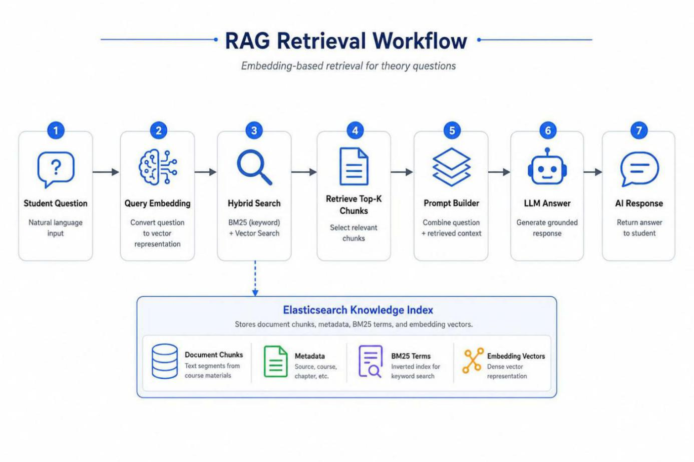
Figure 2. Query embedding, Elasticsearch KNN retrieval, Top-K context selection, prompt construction, and grounded AI response.

3. Knowledge Ingestion Workflow
This figure belongs mainly to the Teacher flow. The current upload pipeline accepts text-based PDF materials; supported website content is imported through a separate flow. Extracted content is chunked and indexed for later student questions.
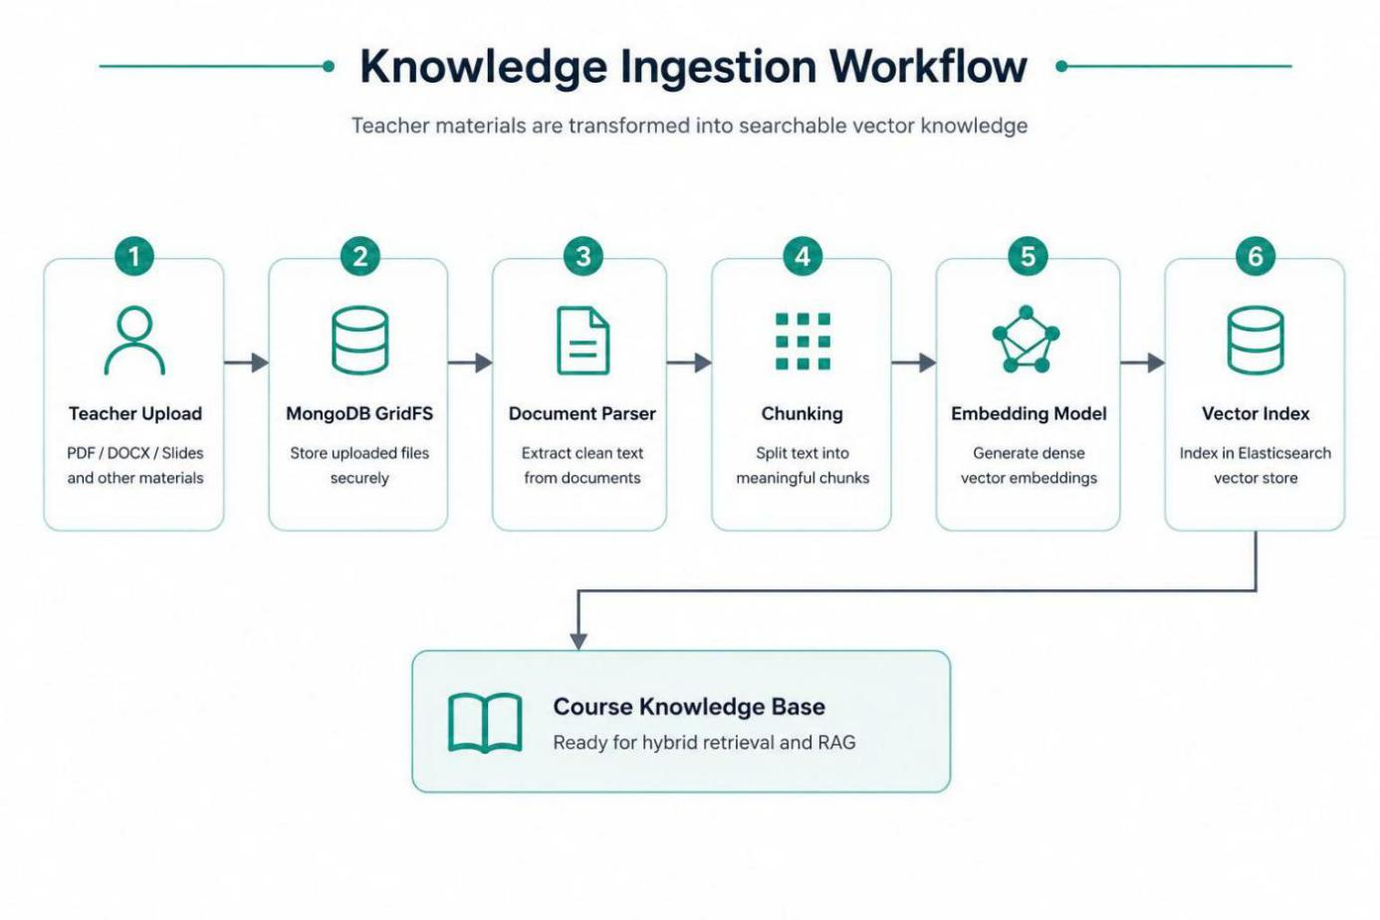
Figure 3. Text-based PDF material ingestion, secure storage, parsing, chunking, embedding, and Elasticsearch vector indexing.
4. Student Review and Escalation Workflow
This figure shows what happens after a student reviews an answer. Helpful feedback is recorded, while questionable answers are sent for human review.
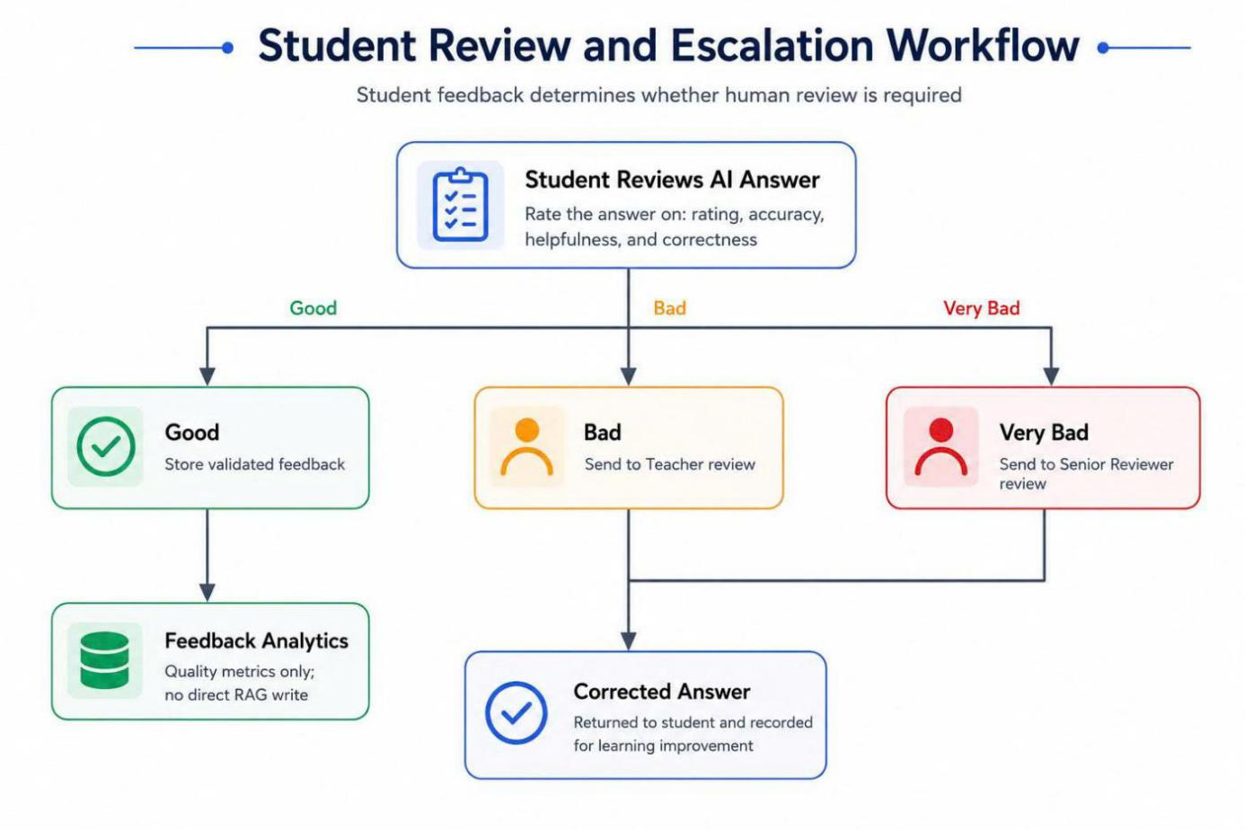
Figure 4. Student feedback routing to analytics, mentor review, or senior review without a direct write to the RAG knowledge base.

5. Human-Validated Knowledge Learning Workflow
This figure connects the Teacher and Administrator flows. A mentor correction becomes reusable knowledge only after senior or administrator approval.
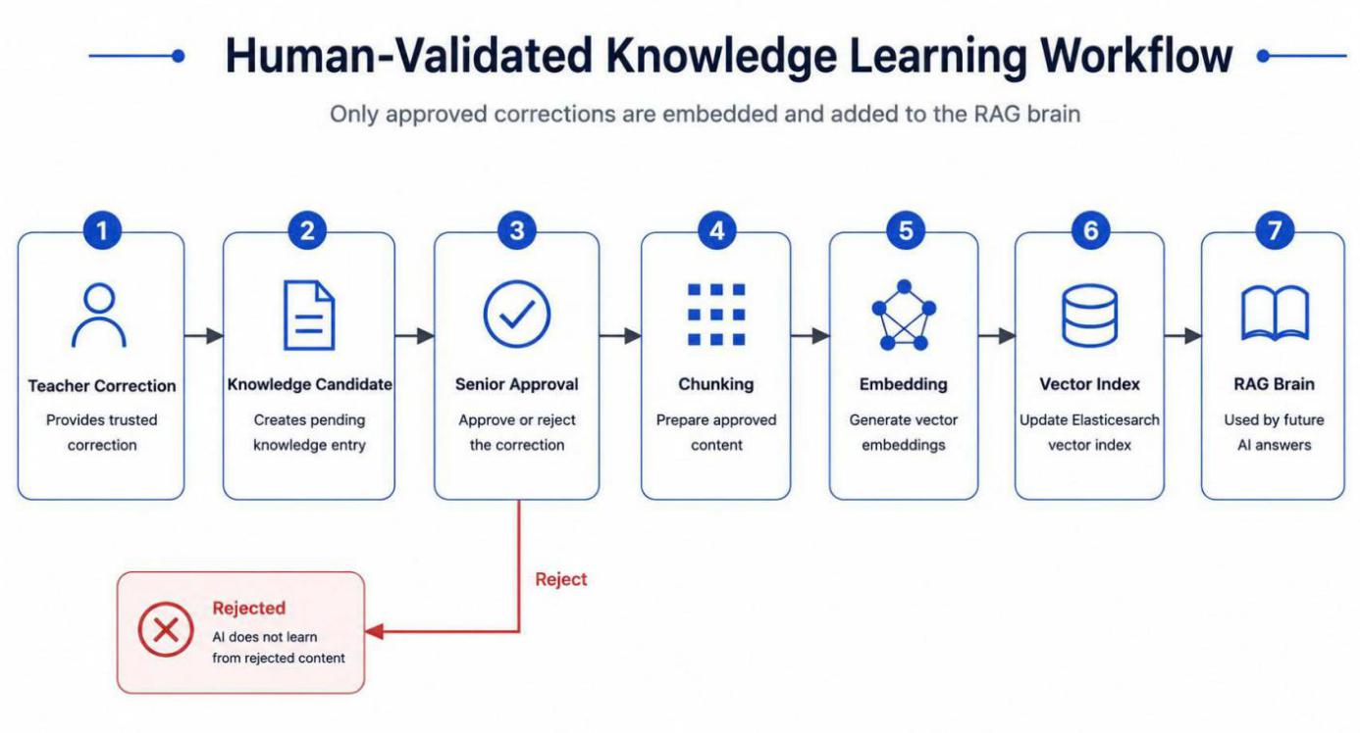
Figure 5. Mentor correction and senior approval gate before chunking, embedding, and reuse by future AI answers.

6. End-to-End Controlled Learning Workflow
This figure summarizes the complete controlled learning loop from a student question to a reviewed improvement for future answers.
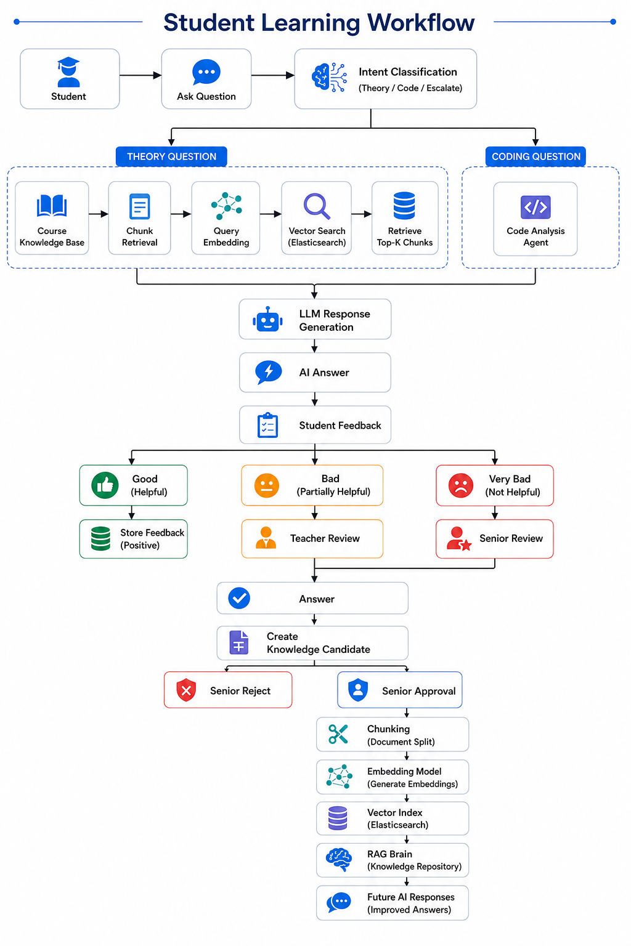
Figure 6. Complete student learning and controlled knowledge-improvement cycle.
Objectives: Based on the current project and user needs, the system will:
Provide a course-scoped AI tutoring channel that answers with evidence retrieved from approved learning materials.

Personalize explanations and follow-up suggestions by maintaining learning memory for each student and course.

Support programming questions through guided code analysis that focuses on explanation, debugging hints, and error understanding instead of completing a full solution for the student.

Route uncertain, disputed, or policy-sensitive questions to a teacher or mentor and preserve the conversation context for human support.

Allow teachers to upload and manage approved theory materials and programming references for Software Engineering courses.

Limit student support to theory questions and guided code analysis within enrolled Software Engineering courses.

Introduce a controlled knowledge-improvement process in which mentor answers and feedback become reusable only after senior approval.

Provide academic administration for Software Engineering semesters, courses, class sections, enrollments, accounts, and operational dashboards.

Keep trace and review records for important AI interactions so incorrect answers can be investigated and corrected.

Main proposal content (including result and product)

Theory and practice (document)

Apply the Scrum framework of Agile methodology and use UML 2.5 to describe requirement specifications and system design.

Apply knowledge from software requirements, software design, web development, testing, project management, database systems, information retrieval, and responsible AI use.

Use a layered web architecture with separate client, service, data, retrieval, and external-AI integration responsibilities.

Prepare product documents including Software Requirement Specification, architecture and detailed design, database design, API specification, test plan and test report, deployment guide, and user guide.

Backend: Java and Spring Boot REST API with Spring Security and role-based access control.

Frontend: React and Vite web application with separate role portals for students, teachers, and administrators.

Data and retrieval: MongoDB/GridFS for operational data and files; Elasticsearch for searchable vector content; an embedding service and an OpenAI-compatible language model for RAG responses.

Workflow integration: n8n may be used as an optional AI harness for intent routing, traceable workflow execution, and fallback orchestration.

Program
Build a web-based AI learning support system for the Software Engineering program with the following role-based functional requirements:
Student
- As a student, I want to sign in and select an enrolled Software Engineering course, so I can access learning support within my authorized course scope.
- As a student, I want to ask a theory question based on approved course materials, so I can better understand Software Engineering concepts.
- As a student, I want to submit a code snippet or programming error, so I can receive guided analysis, debugging hints, and explanations.
- As a student, I want to receive an AI-supported answer with relevant course evidence, so I can evaluate the basis of the response.
- As a student, I want to track my learning and document-research progress, so I can study more proactively.
- As a student, I want to review and rate an answer, so I can report content that is unclear, incorrect, or conflicting.
- As a student, I want to request support from a teacher or mentor, so I can receive human assistance when the system cannot provide a reliable answer.
- As a student, I want to view the status and result of my escalated question, so I can continue my learning process.
Teacher/Mentor
- As a teacher or mentor, I want to view my assigned Software Engineering courses and classes, so I can manage the appropriate academic content.
- As a teacher or mentor, I want to upload and manage approved theory materials and programming references, so students can receive course-specific answers.
- As a teacher or mentor, I want to receive questions that the AI cannot answer reliably, so I can provide timely human support.
- As a teacher or mentor, I want to review the original question, AI answer, retrieved evidence, and conversation context, so I can make an informed academic assessment.
- As a teacher or mentor, I want to correct inaccurate theory or code explanations, so the student can receive an accurate response.
- As a teacher or mentor, I want to propose reusable academic corrections, so validated explanations can improve future answers after approval.
- As a teacher or mentor, I want to track the approval status of my proposed corrections, so I can know whether they were accepted or rejected.
Senior Mentor/Administrator
- As a senior mentor or administrator, I want to view proposed reusable academic knowledge, so I can evaluate its accuracy, scope, and suitability.
- As a senior mentor or administrator, I want to approve or reject proposed academic knowledge, so only verified content is added to the shared RAG knowledge base.
- As a senior mentor or administrator, I want to review disputed or repeatedly reported AI answers, so I can prevent unreliable information from being reused.
- As an administrator, I want to manage accounts and roles, so I can control access to system functions.
- As an administrator, I want to manage semesters, Software Engineering courses, classes, and enrollments, so I can maintain the correct academic structure and access scope.
- As an administrator, I want to monitor the availability of the API, database, search, embedding, and AI services, so I can identify operational problems.
- As an administrator, I want to view trace logs and review records, so I can investigate important AI interactions and approval decisions.
System Handler
- As a system handler, I want to authenticate each user and verify access to the selected course, so I can protect course data and restricted functions.
- As a system handler, I want to classify each request as THEORY, CODE, or ESCALATE, so I can route it to the appropriate processing workflow.
- As a system handler, I want to retrieve relevant approved course knowledge for theory questions, so I can generate grounded answers.
- As a system handler, I want to analyze submitted code and programming errors, so I can provide guided explanations and debugging hints without completing the student's work.
- As a system handler, I want to detect insufficient evidence or unreliable answers, so I can escalate the request to a teacher or mentor.
- As a system handler, I want to preserve the question, conversation context, retrieved evidence, and generated answer during escalation, so the reviewer has enough information to respond.
- As a system handler, I want to keep student feedback and unapproved corrections separate from trusted knowledge, so unverified information cannot affect future answers.
- As a system handler, I want to index only senior-approved reusable knowledge, so the shared knowledge base remains controlled and reliable.
- As a system handler, I want to notify teachers or mentors when a question requires human review, so they can respond promptly.
- As a system handler, I want to notify students when an escalated question has been answered, so they can view the result.
- As a system handler, I want to notify teachers, mentors, and administrators of approval results, so they can track accepted or rejected knowledge proposals.
- As a system handler, I want to record important requests, responses, feedback, escalations, and approval actions, so the workflow remains traceable and auditable.
Other comments (propose all relative things if any)

Limitations and exclusions

The system does not replace a lecturer's academic judgment and does not guarantee that every generated answer is correct.

The system does not automatically grade open-ended assignments; final scores and feedback are entered or confirmed by a teacher.

Code support provides explanations, analysis, and debugging hints; it does not generate a complete assignment, project, or ready-to-submit solution for the student.

Real-time notifications may use polling in the initial release; WebSocket or server-sent event delivery is outside the first scope unless time permits.

The initial release is a web application and does not include native iOS or Android applications.

The system is limited to theory support and guided code analysis for the Software Engineering program. It does not serve other academic disciplines and does not provide quiz management, assignment management, grading, examination, finance, or general student-information functions.

The initial material pipeline prioritizes text-based PDF and supported web content. Scanned documents may require OCR outside the first scope.

n8n orchestration is optional. Deployment and maintenance of a production n8n instance depend on the target environment.

Training a foundation language model from scratch is outside the project scope.

Assumptions and business rules

Course and enrollment information is provided by authorized academic staff and is treated as the source of access scope.

A student may query and download only content belonging to an enrolled course and class, subject to the assigned permissions.

Teacher-uploaded materials must be associated with the correct course, and class-specific materials retain their class context.

An AI answer with insufficient evidence may be escalated instead of being presented as a confident conclusion.

Student feedback, a teacher answer, or a negative rating does not update the shared RAG knowledge base by itself.

Only reusable academic knowledge approved by a senior mentor or administrator is indexed into the shared knowledge base.

Deadlines, grades, one-class policies, and assignment-specific decisions are not generalized into reusable AI knowledge.

Third-party model, embedding, e-mail, and workflow services are available and configured in the deployment environment.

Sensitive configuration values and credentials are stored outside source code and access is controlled by role.

Suggested work allocation (adjust after the final team is confirmed)

Student 1: project planning, requirements, common UI foundation, authentication, and Student Portal.

Student 2: Teacher Portal, Software Engineering learning materials, escalated-question review, and teacher-support interfaces.

Student 3: Spring Boot APIs for users, Software Engineering courses, enrollments, conversations, reviews, and administration.

Student 4: RAG ingestion and retrieval, guided code analysis, escalation, human-review workflow, n8n integration, deployment, and monitoring.

Supervisor (If have)  (Sign and full name) | Ho Chi Minh City, March 22, 2024  On behalf of the Registers  (Sign and full name)

Kiều Trọng Khánh TNHH Lương Đức Tín

